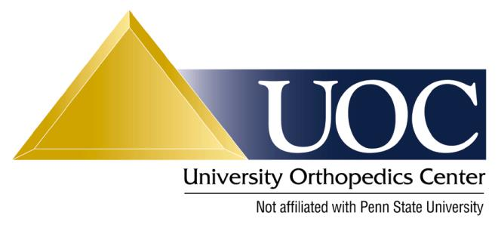

Physical Therapy Protocol: Reverse Shoulder Replacement

This protocol is a guideline. Each patient’s therapy should be individualized based on his/her injury severity and response to treatment. Please contact Dr. Van Kleunen with any questions.

Postoperative period
0 to 6 weeks:
1. 1 visit per week, everyday home program with goals.
2. Cryotherapy at least 5 times per day, 20 minutes each application.
3. Sling is always to be worn (including for sleep); however, sling should be removed for exercises.
4. Avoid any active shoulder motion during this period (particularly avoid active IR to allow subscapularis to heal).
5. Active and passive range of motion of the neck, wrist, and hand 5 times per day.
6. Gentle passive pendulums exercises should be started immediately and performed 3 times per day.
7. Avoid passive ER past 20°, passive forward flexion past 130°, and extension past neutral.
8. Avoid combined adduction, extension, and internal rotation
9. Discontinue abduction pillow at 4 weeks.

6 weeks to 3 months:
1. 1 to 2 visits per week, 5 times per week home program with goals.
2. Begin to wean from sling at 6 weeks.
3. PROM and AAROM in all planes of shoulder motion as tolerated but avoid combined adduction, extension, and internal rotation. Do not begin IR until 6 weeks.
4. Advance ER of the shoulder gently and to pain tolerance up to 60°.
5. Periscapular strengthening and ROM exercises including shoulder shrugs and scapular retraction exercises.
6. May perform Jackin’s deltoid exercises.
7. Begin gentle closed/open chain strengthening and stabilization at 8 weeks.
8. Emphasis on regaining full shoulder motion.

3 to 6 months:
1. 1 to 2 visits per week, 5 times per week home program with goals.
2. A strong emphasis on periscapular strengthening and ROM exercises with scapular protraction, retraction, and elevation.
3. Rotator cuff strengthening exercises (with bands/dumbbells) may begin once AROM is full.
4. Begin gradual return to previous sport/activities/work duties under controlled conditions.
5. Full return to previous sport/activities/full work duties are pending Dr. Van Kleunen’s approval based upon the following criteria:

Criteria for Return to Sports/Full Activities:
1. Full functional ROM.
2. No pain or tenderness.
3. Satisfactory muscle strength.
4. Satisfactory clinical examination.

