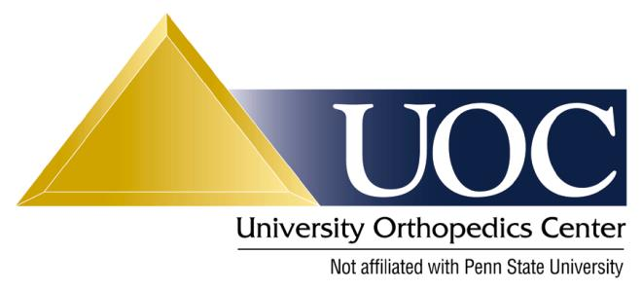

Physical Therapy Protocol: Total Shoulder Replacement/Hemiarthroplasty

This protocol is a guideline. Each patient’s therapy should be individualized based on his/her injury severity and response to treatment. Please contact Dr. Van Kleunen with any questions.

Postoperative period
0 to 6 weeks:
1. 1 visit per week, everyday home program with goals.
2. Cryotherapy at least 5 times per day, 20 minutes each application.
3. Sling is always to be worn (including for sleep); however, sling should be removed for exercises.
4. Avoid any active shoulder motion during this period (particularly avoid active IR to allow subscapularis to heal).
5. Active and passive range of motion of the neck, wrist, and hand 5 times per day.
6. Gentle passive pendulums exercises should be started immediately and performed 3 times per day.
7. Avoid passive ER past 30° and passive forward flexion past 130°
8. Discontinue abduction pillow at 4 weeks.

6 weeks to 3 months:
1. 1 to 2 visits per week, 5 times per week home program with goals.
2. Begin to wean from sling at 6 weeks.
3. May progress PROM, AAROM w/o resistance as tolerated. No IR until 6 weeks, 45° at 8 weeks, and 60° at 12 weeks.
4. Advance ER of the shoulder gently and to pain tolerance (subscapularis is healing).
5. Periscapular strengthening and ROM exercises including shoulder shrugs and scapular retraction exercises.
6. Begin gentle open/closed stabilization and strengthening @ 8 weeks.
7. Emphasis on regaining full shoulder motion.

3 to 6 months:
1. 1 to 2 visits per week, 5 times per week home program with goals.
2. Continue exercises in previous phase.
3. A strong emphasis on periscapular strengthening and ROM exercises with scapular protraction, retraction, and elevation.
4. Rotator cuff strengthening exercises (with bands/dumbbells) may begin once AROM is full.
5. Begin gradual return to previous sport/activities/work duties under controlled conditions.
6. Full return to previous sport/activities/full work duties are pending Dr. Van Kleunen’s approval based upon the following criteria:

Criteria for Return to Sports/Full Activities:
1. Full functional ROM.
2. No pain or tenderness.
3. Satisfactory muscle strength.
4. Satisfactory clinical examination.

